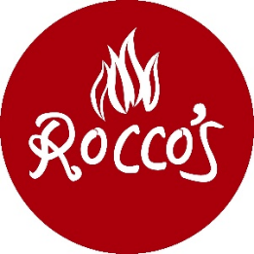
Wednesday, February 18, 2026

Small Plates
Classic Shrimp Cocktail
Cocktail sauce, lemon 19

PEI Mussels
White wine, lemon butter, garlic 22

Burrata
Prosciutto, arugula, balsamic, grilled bread 21

Large Plate
Rocco’s Fish Fry
House made tartar sauce, classic coleslaw, macaroni salad, french fries 26

House Made Manicotti
House made crepes, ricotta, Rocco’s sauce, mozzarella 30
Add a meatball 7

Crab and Lobster Ravioli
Lemon butter sauce, rock shrimp, peas, tomatoes, toasted bread crumbs 38

Blackened Halibut
Marinated ruby red grapefruit w/ fennel & olives, feta-sweet pea farro salad 43

Twin Filet Mignon
Asparagus tortelloni, mushroom marsala sauce, bread crumbs, chives 46

